
Holy Cross College

Semester 2 Examination 2017

Question/Answer Booklet

Year 10 Science
Please place your student identification label in this box
(General)
Physics

Student Name
Student’s Teacher

Time allowed for this paper

Reading time before commencing work: 10 minutes
Working time for paper: 100 minutes

Materials required/recommended for this paper

To be provided by the supervisor

This Question/Answer Booklet
Data Sheet

To be provided by the candidate

Standard items: pens, pencils, eraser, correction fluid, ruler, highlighters.
Special items: non-programmable calculators satisfying the conditions set by the School Curriculum and Standards Authority for this course.

Important note to candidates

No other items may be taken into the examination room. It is your responsibility to ensure that you do not have any unauthorised notes or other items of a non-personal nature in the examination room. If you have any unauthorised material with you, hand it to the supervisor before reading any further.

Structure of this paper

Section | Number of questions available | Number of questions to be answered | Suggested working time  (minutes) | Marks available | Percentage of exam
Section One:  Multiple Choice | 30 | 30 | 15 | 30
Section Two:  Short Answer | 10 | 10 | 35 | 54
Section Three:
Comprehension
 |  |  |  | 84 | 100

Instructions to candidates

1. The rules for the conduct of examinations at Holy Cross College are detailed in the College Examination Policy. Sitting this examination implies that you agree to abide by these rules.

2. Write your answers in this Question/Answer Booklet.

3. Working or reasoning should be clearly shown when calculating or estimating answers.

4. You must be careful to confine your responses to the specific questions asked and to follow any instructions that are specific to a particular question.

5. Spare pages are included at the end of this booklet. They can be used for planning your responses and/or as additional space if required to continue an answer.

• Planning: If you use the spare pages for planning, indicate this clearly at the top of the page.
• Continuing an answer: If you need to use the space to continue an answer, indicate in the original answer space where the answer is continued, i.e. give the page number.
• Fill in the number of the question(s) that you are continuing to answer at the top of the page.

SECTION 1 MULTIPLE CHOICE (30 marks)

Choose the best answer for each question in the Multiple Choice Question booklet.

Mark your selection with a cross.

1 | (a) | (b) | (c) | (d)
2 | (a) | (b) | (c) | (d)
3 | (a) | (b) | (c) | (d)
4 | (a) | (b) | (c) | (d)
5 | (a) | (b) | (c) | (d)
6 | (a) | (b) | (c) | (d)
7 | (a) | (b) | (c) | (d)
8 | (a) | (b) | (c) | (d)
9 | (a) | (b) | (c) | (d)
10 | (a) | (b) | (c) | (d)
11 | (a) | (b) | (c) | (d)
12 | (a) | (b) | (c) | (d)
13 | (a) | (b) | (c) | (d)
14 | (a) | (b) | (c) | (d)
15 | (a) | (b) | (c) | (d)
16 | (a) | (b) | (c) | (d)
17 | (a) | (b) | (c) | (d)
18 | (a) | (b) | (c) | (d)
19 | (a) | (b) | (c) | (d)
20 | (a) | (b) | (c) | (d)
21 | (a) | (b) | (c) | (d)
22 | (a) | (b) | (c) | (d)
23 | (a) | (b) | (c) | (d)
24 | (a) | (b) | (c) | (d)
25 | (a) | (b) | (c) | (d)
26 | (a) | (b) | (c) | (d)
27 | (a) | (b) | (c) | (d)
28 | (a) | (b) | (c) | (d)
29 | (a) | (b) | (c) | (d)
30 | (a) | (b) | (c) | (d)

SECTION 2 SHORT ANSWER (54 marks)

Attempt all questions. Write your answers in the spaces provided.

1. How long will it take to complete a trip by car from Perth to Kalgoorlie, a distance of 595 km, travelling at an average speed of 85 km/h? (Give your answer in hours.) (3 marks)

2. Vincent dropped a stone down a well and saw it hit the bottom 3.5 s later. Calculate the velocity of the stone at impact, given the acceleration due to gravity is 9.80 m/s² and the stone starts from rest. (3 marks)

3. Sean steps on the brake pedal of his car for 2.5 s. This applies a retarding force of 2100 N to slow his 750 kg car, which is travelling in an easterly direction. Calculate his car's deceleration. (3 marks)

4. Consider the forces acting on the car in the diagram below.

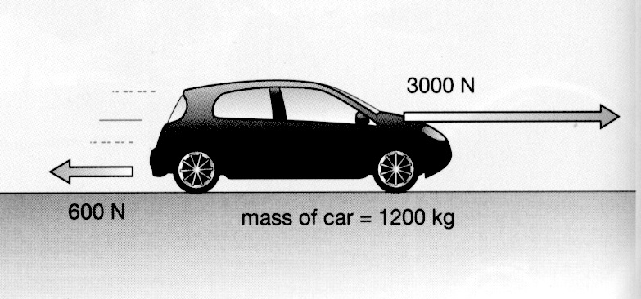

(a) Calculate the nett force acting on the car. (2 marks)

(b) Calculate the acceleration of the car, given its mass is 1200 kg. (3 marks)

5. Max has a mass of 57 kg on Earth. He is lucky enough to be selected for a junior astronaut programme and journeys to the International Space Station (ISS) for a
3-month stay.

(a) Calculate Max's weight on Earth, where the acceleration due to gravity is
9.80 m/s². (3 marks)

(b) Max "floats” in space within the ISS. Is he weightless? Explain your answer.
(2 marks)

(c) Is Max ever weightless in space? Explain your answer. (2 marks)

6. A force of 36 N acts on a mass of 24 kg. What is the acceleration of the mass?
(3 marks)

7. A mass of 28 kg is brought to rest by an average force of 98 N acting backwards in 5.0 s.

(a) What is the deceleration of the mass? (3 marks)

(b) Calculate the initial velocity of the mass. (3 marks)

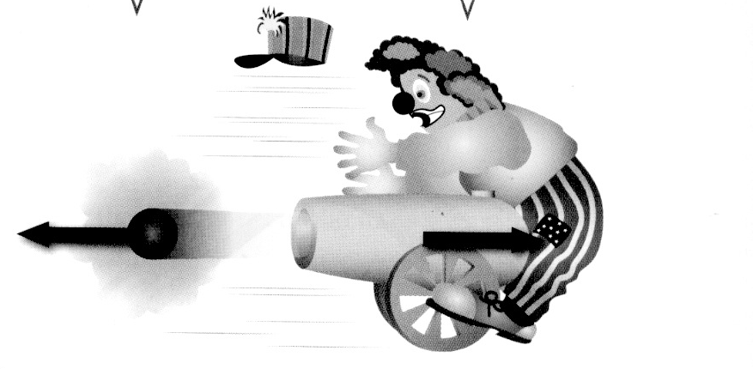
8. Look at the diagram showing a clown and a cannon at a circus.
(a) Which of Newton's three laws applies to this situation? (1 mark)

(b) Explain clearly why the cannon hits the clown. (2 marks)

9. At the 2016 Singapore Grand Prix, Daniel Ricciardo accelerates quickly from the start and reaches 285 km/h (79.2 m/s) after 4.7 s. He is nearly at the first corner.

(a) Calculate the average acceleration of the car. (3 marks)

(b) Ricciardo is still travelling at 285 km/h (79.2 m/s) when he has to brake strongly to reduce the speed of the car to 110 km/h (30.6 m/s) to make it around the first corner. Given that the mass of the car is 780 kg and it takes 1.2 s to slow the car, calculate:

(i) the deceleration of the car. (3 marks)

(ii) the average force exerted by the brakes. (3 marks)

(c) At the start of the race, a car was hit and sent sideways into the rubber tyre wall, which acts as a safety device to protect the drivers.

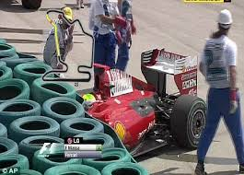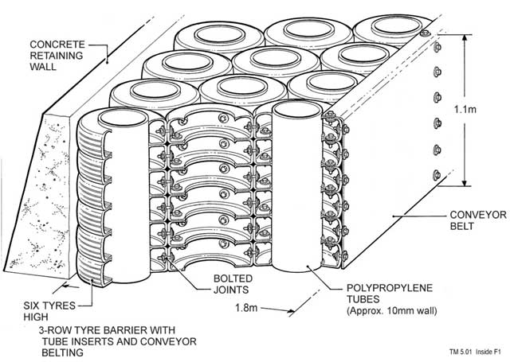

(i) Explain the Physics principle behind how the tyre wall acts as a safety barrier to protect the driver.
(2 marks)

(ii) Tyre walls are around every corner on the track. When a car loses grip and starts to slide, it goes off the track in a straight line, even if it is skidding sideways.

Which of Newton's three laws applies to this situation? (1 mark)

Explain clearly why this happens. (2 marks)

(d) During the race, Ricciardo set a new race lap record of 110.041 seconds
(1 min 50.041 s). Given the track is 5065 m long, calculate his average speed for the lap. (3 marks)

10. Tim and Peter are good friends who live in the Rivervale area. Tim was planning to walk from his place to Peter's and the map below shows their respective houses. Use the map to do the following.

(a) Trace on the map the way you would walk to Peter's house. Using the scale, calculate (approximately) the distance you would walk. (2 marks)

(b) Determine the displacement and bearing (or direction) you would have after the walk.
(3 marks)

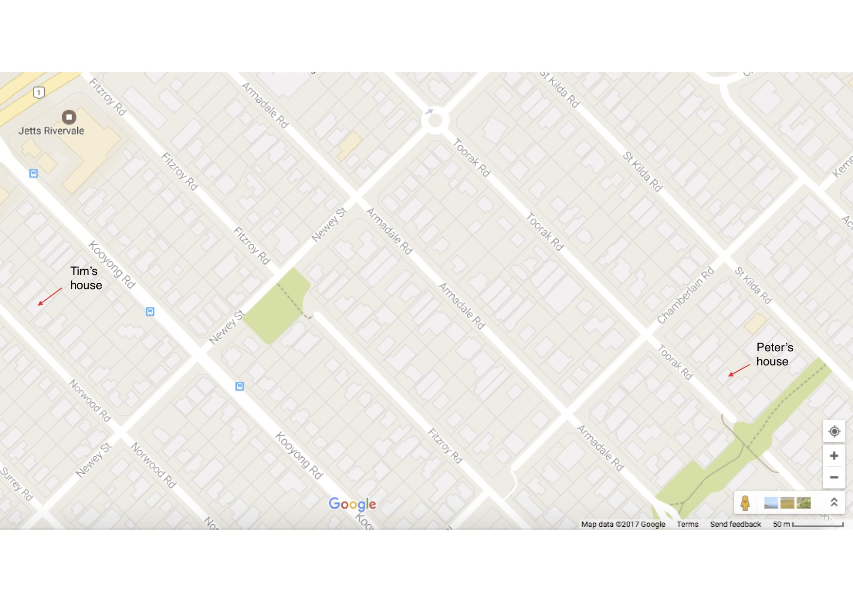

END OF EXAMINATION
ADDITIONAL WORKING SPACE
ADDITIONAL WORKING SPACE
ADDITIONAL WORKING SPACE

ADDITIONAL WORKING SPACE

